Below is the ERD for the Kilowatt Database. These are the high level tables and relationships, but we will also need the below forms from Access. The below forms will be integrated in the application in a more modern way.

* Account Procurement Form
* Pricing Form
* Commission Schedule Form
  + Enter information from each confirm.
* ESIID Data Subform
* Rep Split Form
  + Add information for a provider.
* ESIID Split form
  + Wiley looks at this to gain insight on accounts.

[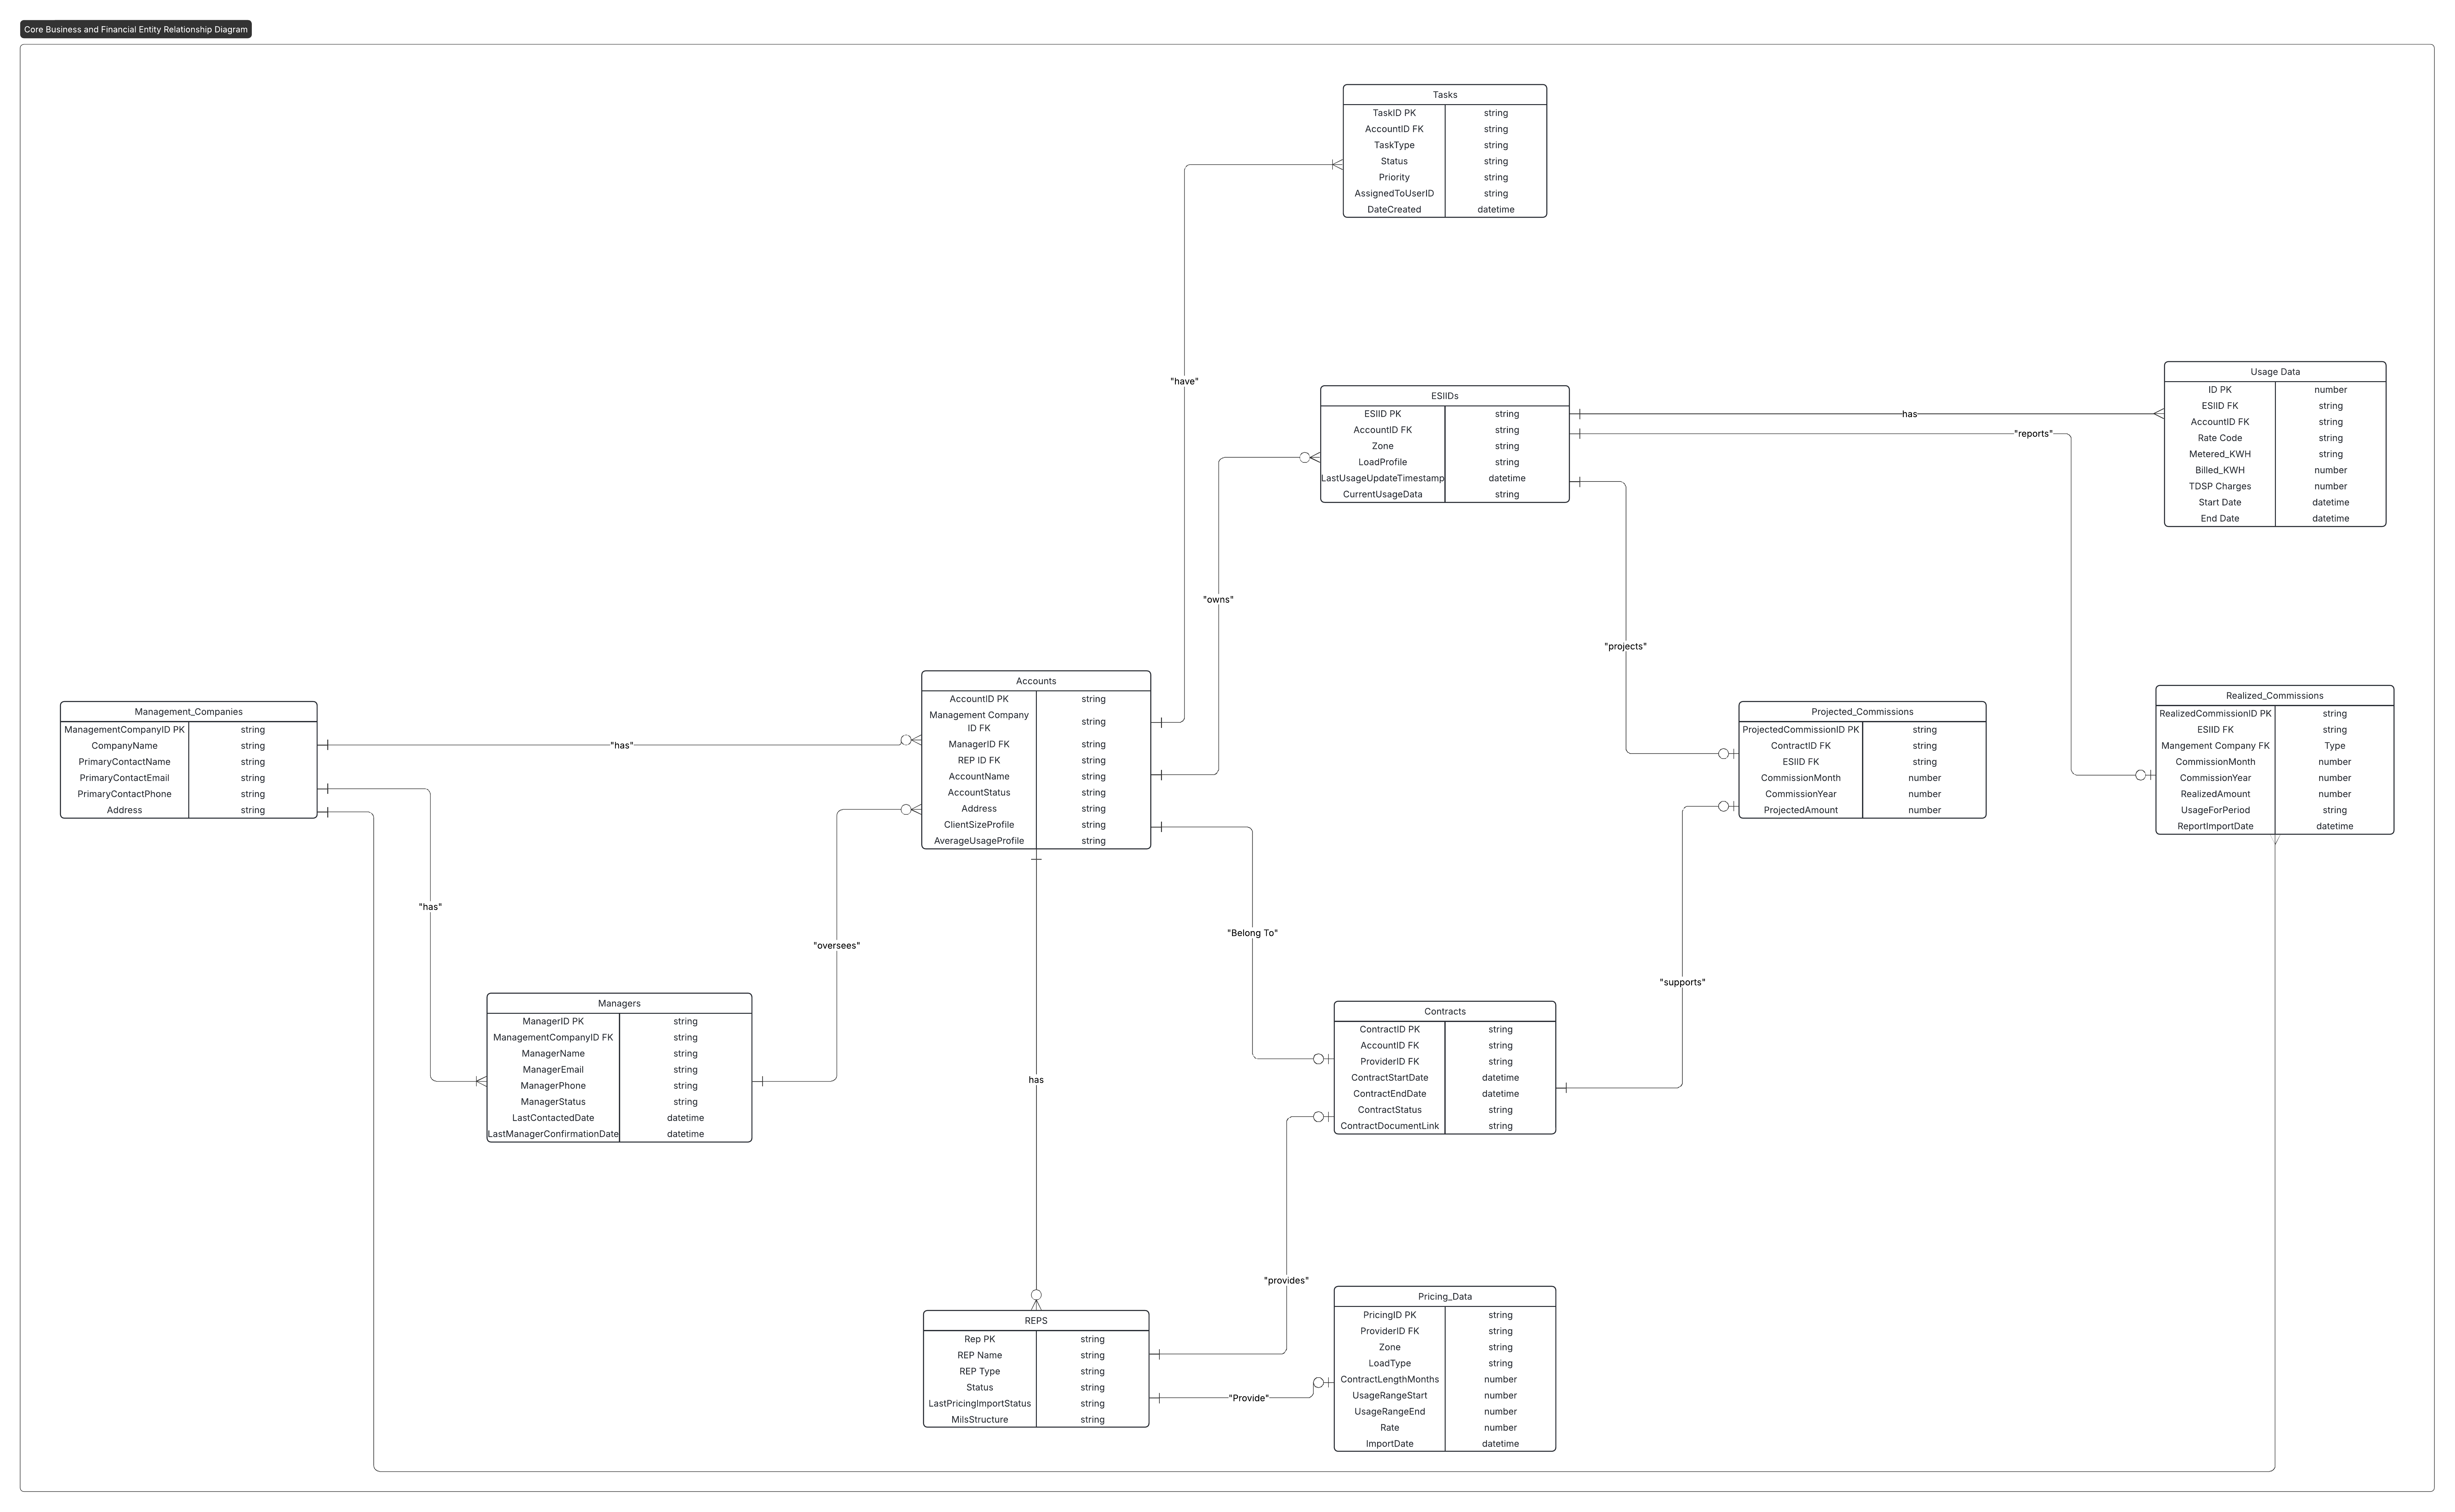](https://lucid.app/lucidchart/8930a222-97fd-4138-9b72-81435b4c22b0/edit?crop=content&page=0&signature=379effc89d47ed5aedc69add35ae1426108c27f436c833dacffb726290bec174)